Vviewpoints

DOI:10.1145/3539783 Charles Isbell, Michael L. Littman, and Peter Norvig
Viewpoint

Software Engineering of Machine Learning Systems
Seeking to make machine learning more dependable.

IMAGE BY ARTEMISDIANA
MACHINE LEARNING (ML) is

ubiquitous, contributing to society-facing applica-tions that each day im-pact how we work, play,

communicate, live, and solve problems. In 2015, after Marc Andreesen pro-claimed “software is eating the world,” others countered “machine learning is eating software.” While there have been exciting ACM A.M. Turing-award-winning worthy advances in the science of ML, it is important to remember ML is not just an academic subject: it is a technology used to build software that is consequential in the real world.

Failures of ML systems are com-monplace in the news: IBM’s Oncology Expert Advisor project is canceled for poor results after a $60 million invest-ment; the chatbot Tay learns abusive language; an Uber self-driving car runs a red light; a Knightscope security robot knocks over a toddler;8 facial recogni-tion systems unfairly make three times more errors for non-white non-males.2

For 50 years, the software engineer-ing (SE) community has been learning from its own failures and introducing new tools, techniques, and processes to make better software. To build ro-bust, reliable, safe, fair systems with ML, we need all these established SE techniques, and some new ML-spe-cific ones. In turn, software engineers should realize how ML can change the way software is developed. Our goal in this Viewpoint is to pull together some of the threads that relate to this topic to spur more conversation about put-

ting these ideas into practice. Ignoring these insights will lead to unprecedent-ed levels of technical debt. In brief, we believe that ideas from software engi-neering such as explicit requirements, testing, and continuous integration need to be embraced by teams that are making systems built on top of data.
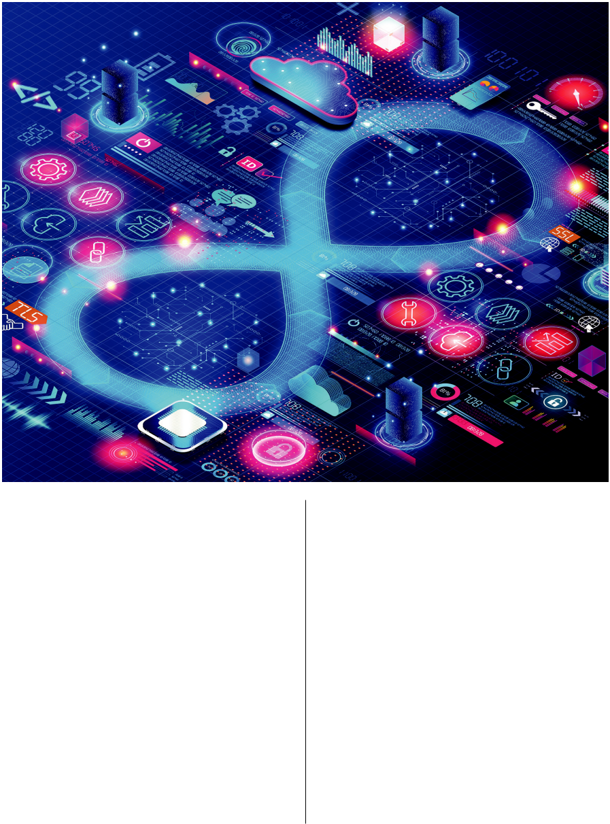

Software Engineering Basics

In some organizations, machine learn-ing researchers develop ML algorithms using R or Python notebooks without basic software engineering tools like type checking, reusable modules, ver-sion control, unit tests, issue tracking,

system and process documentation, code reviews, postmortems, automat-ed hermetic builds, and continuous monitoring. This lack of discipline is an avoidable source of failures—or-ganizations should insist on standard SE practices from their ML teams. ML researchers should be encouraged to use the same tools and pipelines that will be used in production, heeding the emerging machine learning opera-tions (MLOps) techniques. As the NASA saying goes, “Test what you fly, fly what you test.” Including software engineer-ing education as part of the data sci-ence curriculum will help newly mint-

FEBRUARY 2023 | VOL. 66 | NO. 2 | COMMUNICATIONS OF THE ACM 35

viewpoints

Distinguished Speakers Program


A great speaker can make the difference between a good event and a WOW event!

Take advantage of

ACM’s Distinguished

Speakers Program to invite renowned thought leaders in academia, industry, and government to deliver virtual or in-person talks on important topics in computing. ACM covers the cost of transportation for speakers to travel to in-person events.

speakers.acm.org

ed students appreciate how important these processes are to help them meet their responsibilities.

Taking Data Seriously

Every software program deals with is-sues of verifying data, keeping it se-cure and private, and scaling up to big data when needed. But in ML the stakes are raised because algorithms learn from the data, so a data error can lead, not just to a problem for one cus-tomer, but to decreased performance for every customer.

Organizations should employ a data pipeline that tracks the provenance of all data, allows it to be annotated, managed, and abstracted, and protects the privacy of personally identifiable or proprietary data. Promising tech-nologies including differential privacy, federated learning, and homomorphic encryption are key tools for privacy, but are in varying stages of maturity .

ML teams must have separate train-ing, validation, and test datasets, which should not accidentally become inter-twined as the design space is explored. Teams can fool themselves by running experiments until the results look good, and then stopping. At that point, they cannot be sure if the last good results are truly representative of future per-formance, or if the results will regress back to the mean. Teams must protect themselves by adhering to an experi-mental design and stopping rules.

Many ML algorithms include ran-domness, so different training runs may produce different results. More thorough testing is needed as a conse-quence. Throughout the development process, developers must acknowledge that the fingerprints of the human en-gineers are all over the final result, for better and for worse.

When example data comes from us-ers, ML systems are vulnerable to mis-takes and intentional attacks by these users. The site labelerrors.com cata-logs labeling errors in popular crowd-sourced image databases (such as label-ing a dingo as a coyote), which corrupts systems that train on this data. Worse, adversaries who can contribute as little as 1% of the training data can poison the data, allowing them to exploit an ML system such as an email spam fil-ter.7 To guard against these attacks, we must verify data as well as software,

and promote “adversarial thinking” throughout the educational pipeline so system designers know how to defend against malevolent actors.

Optimizing the Right Thing

In traditional software engineering, the requirements say what should be achieved, and programmers design and develop an implementation that meets the requirements, verifying their choice of how satisfies what must be done. With ML, computation becomes a partner in this translation process: Programmers state what they want achieved by supplying training exam-ples of appropriate (and inappropri-ate) behavior and defining an objective function that measures how far off the implementation is from the require-ments. A learning algorithm then takes the training examples and objective func-tion and “compiles” them into a program that ideally produces success on future examples. If we get the data and require-ments right, the software “writes itself.”

Unfortunately, the reality of ML is it is difficult to precisely and unequivo-cally say what you want. ML algorithms will exploit loopholes in the require-ments. A Roomba that was instructed not to bump into furniture learned to drive backward, because there were no bumper sensors on the rear. Video-game-playing programs were instructed to achieve the highest score, and did so not by playing the game, but by writing their name in the list of high scorers.4

Expressing requirements as objec-tive functions can surface their latent contradictions. For example, the law requires equitable treatment of pro-tected classes in employment, hous-ing, and other decision-making sce-narios.5 When writing requirements for a system to predict whether a de-fendant will commit a crime in the future, we need to translate this “eq-uitable treatment” law into an objec-tive function. One requirement is that predictions are equally accurate for, say, both Black and white defendants. Another requirement is that the harm done by bad predictions affects Black and white defendants equally. Unfortu-nately, it is not possible to achieve both these requirements simultaneously.6 ML developers, in consultation with all stakeholders, must decide how to make trade-offs in objectives.

36 COMMUNICATIONS OF THE ACM | FEBRUARY 2023 | VOL. 66 | NO. 2

Building Trust

A successful software system must not only get the right answers, but also con-vince the developers and users to trust the answers. As ML software is increas-ingly being tasked with highly sensitive decision making in areas such as hir-ing, medical treatment, lending, and criminal sentencing, we have to ensure such systems are fair, transparent, ac-countable, auditable, explainable, and interpretable. We must determine what sort of explanations will justify treatment of an individual; what kind of tests will certify robust system per-formance across likely use cases; what type of auditing and reporting will demonstrate fairness across diverse protected classes; and what remedia-tion processes are available when there are errors. Doing so is difficult because ML systems are often used for the most complex and ill-defined tasks—if the tasks were easy, we would not need an ML solution.

For example, despite enthusiasm for ML classifiers in medical imaging and despite many systems achieving 95%+ accuracy,1 there are still few de-ployed systems, because ML engineers have not yet convinced doctors the sys-tems are robust across different X-ray machines, different hospital settings, and so forth. Without better assurance, there is insufficient reason to believe such high accuracy will persist in the wild, resulting in poor outcomes.

Traditionally, programmers try to write code that is general enough to work even in cases that were not test-ed. In ML systems, it is hard to predict when a training example will general-ize to other similar inputs, and when the example will be memorized by the system with no generalization. We need better tools for understanding how ML systems generalize.

In traditional software, major up-dates are infrequent, leaving suffi-cient time to thoroughly test them. Small patches are localized, and thus only require testing the parts that are changed. But in ML systems such as Internet search and product recom-mendations, new data is arriving con-tinuously and is processed automati-cally, often resulting in unbounded nonlocal changes to ML models. ML developers need to be prudent about how often they retrain their models

We need better tools for understanding how ML systems generalize.

on new data—too frequently and it will be difficult for quality assurance teams to do thorough testing; too rare-ly and the models become stale and inaccurate. We need better tools for tracking model evolution. In addition to tracking new data, we need a pro-cess for discarding old data, as when a major event like a new social media platform or a pandemic significantly alters the data models rely on. Avoid-ing downstream trouble due to such data cascades takes vigilance , as well as inputs from domain experts and from “softer” fields such as human-computer interaction.

Verification of traditional software relies on abstractions that let us divide the system into components that are composable, modular, interpretable, and often reusable. Current methods for building ML systems do not typi-cally lead to models with these prop-erties. Rather, each new ML system is built from scratch, and each resulting model is largely a black box requiring significant work to understand and verify. One promising approach is a class of multitask unified models6 that share internal structure across related tasks, data sets, and languages. More effort can go into verifying a single large model, which can then be spe-cialized for new tasks.

Diverse Viewpoints

It is easy to create, say, a calculator pro-gram, because all users agree that the answer to 12×34 should be 408. But for many ML problems the desired an-swers are personalized for each user. That means that we need to do bal-anced data collection, particularly for underrepresented groups, to assure that each group gets the answers they need. We cannot let the data of the ma-jority undermine proper answers for minority classes.
viewpoints

To properly serve a diverse popu-lation of users and use cases, ML de-velopment teams should be diverse themselves, and should be trained to consider diverse needs, and not to be satisfied with existing data sets that are unbalanced in their coverage.

Society Needs Us

There can be many sources of bugs in ML programs: traditional bugs in the implementation of the algorithm; in-valid, incomplete, or unrepresentative data; incompleteness in the specifica-tion of objectives; poor choices of hy-perparameters; and more.

Now that ML software is rapidly expanding in its prevalence, conse-quence, and influence on our lives, it is clear we need careful, professional methodologies designed to encour-age the positive while moderating the negative impacts of this technology on society. We must build tools to sup-port these methodologies, train people to use them, and develop certification systems that reassure users and mini-mize failures.

Making ML dependable will require new research and new practice. It will require machine learning researchers thinking like software engineers and software engineering researchers think-ing like machine learning practitioners. The consequences are too dire to do anything else.

References

- Aggarwal, R. et al. Diagnostic accuracy of deep learning in medical imaging: A systematic review and meta-analysis. Digit. Med . 4, 65 (2021).

- Grother, P. et al. Face Recognition Vendor Test (FRVT). National Institute of Standards and Technology, (Dec. 2019).

- Kleinberg, M. et al. Inherent Trade-Offs in the Fair Determination of Risk Scores. CoRR, (2016).

- Krakovna, V. and Uesato, J. et al. Specification gaming: The flip side of AI ingenuity. DeepMind Blog, (Apr. 2020).
- Mehrabi, N. and Morstatter, F. et al. A Survey on Bias and Fairness in Machine Learning, CoRR , (2019).

- Nayak, P. MUM: A new AI milestone for understanding information. The Keyword (Google Blog), (May 2021).

- Nelson, B. et al. Exploiting Machine Learning to Subvert Your Spam Filter. In Proceedings of LEET’08, (2008).
- Partnership on AI, Artificial Intelligence Incident Database (2021); https://incidentdatabase.ai/

Charles Isbell (isbell@cc.gatech.edu) is Dean of the College of Computing and The John P. Imlay Jr. Chair at Georgia Tech in Atlanta, GA, USA.

Michael L. Littman (mlittman@cs.brown.edu) is a University Professor at Brown University in Providence, RI, USA, and was on leave at Georgia Tech at the time this Viewpoint was written.

Peter Norvig (peter@norvig.com) is a Distinguished Education Fellow at Stanford University in Stanford, CA, USA, and Research Director at Google.

Copyright held by authors.

FEBRUARY 2023 | VOL. 66 | NO. 2 | COMMUNICATIONS OF THE ACM 37

Copyright of Communications of the ACM is the property of Association for Computing Machinery and its content may not be copied or emailed to multiple sites or posted to a listserv without the copyright holder's express written permission. However, users may print, download, or email articles for individual use.

